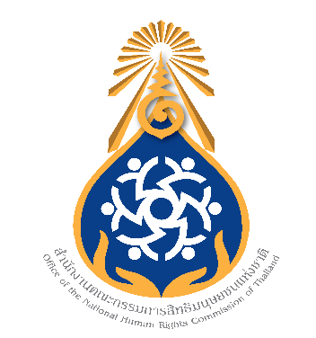

The NHRCT to investigate the clash between police officers and protesters on the night of 28 February and the investigation report on late 2020 political demonstrations to be released soon
On 3 March 2021, Mrs. Prakairatana Thontiravong, Acting Chairperson of the National Human Rights Commission of Thailand (NHRCT) revealed that the NHRCT, at the meeting
No. 11/2564 on 2 March 2021, resolved to bring up the incident of clash between police officers and protesters on the night of 28 February for investigation. It took place near the 1st Infantry Regiment barracks when the protesters named "REDEM" announced to march to the Prime Minister's residence. The protesters threw things at police during confrontation. The police tightened the area and dispersed the protest by using water cannons, tear gas and rubber bullets. There were a number of injuries and a police officer died reportedly due to heart failure. The investigation will be conducted together with the previous case of police officers allegedly assaulting a medical volunteer on 13 February 2021.
Mrs. Thontiravong said that the case was quite sensitive as it was variedly reported through media channels. The NHRCT will carefully and comprehensively investigate the incident and it may be necessary to also invite experts to give their views. She affirms that the NHRCT will speedily and impartially conduct the investigation, considering the compliance with international human rights standards.
“As for the political demonstrations occurred during July – December 2020, the NHRCT has completed the investigation of human rights violation and is in the process of preparing the report with recommendations. The report is expected to be publicly published soon.” the Acting Chairperson said.
***********************
Office of the National Human Rights Commission of Thailand
3 March 2021

